NAME: GAURAV GARG

UID: 22BCS15846

SECTION: FL_IOT_603-A

1763.[Longest Nice Substring](https://leetcode.com/problems/longest-nice-substring/description/)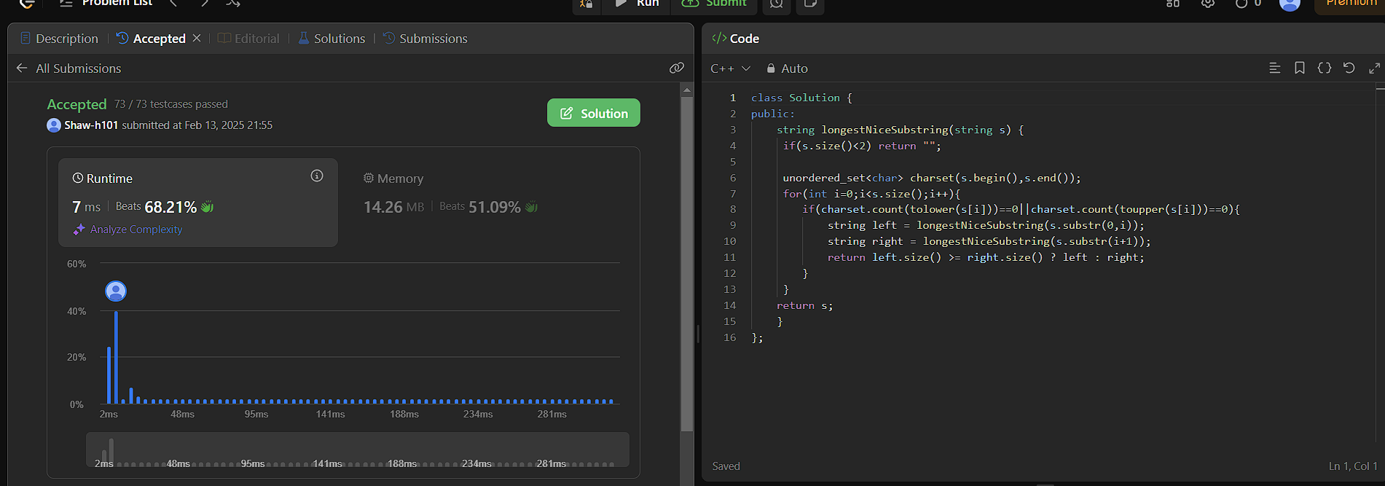

190.[Reverse Bits](https://leetcode.com/problems/reverse-bits/description/)

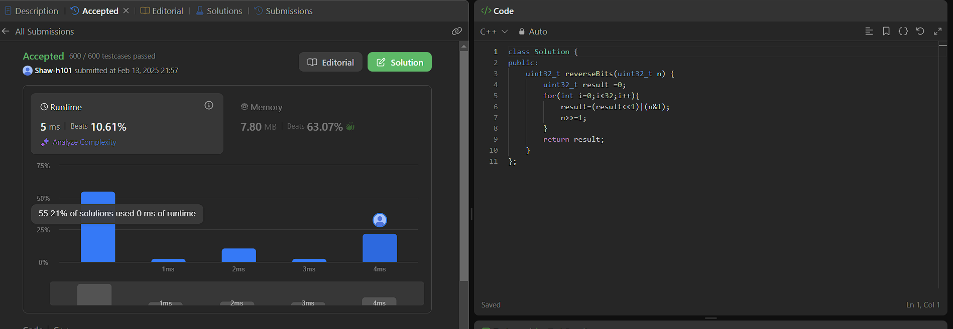

191.[Number of 1 Bits](https://leetcode.com/problems/number-of-1-bits/description/)

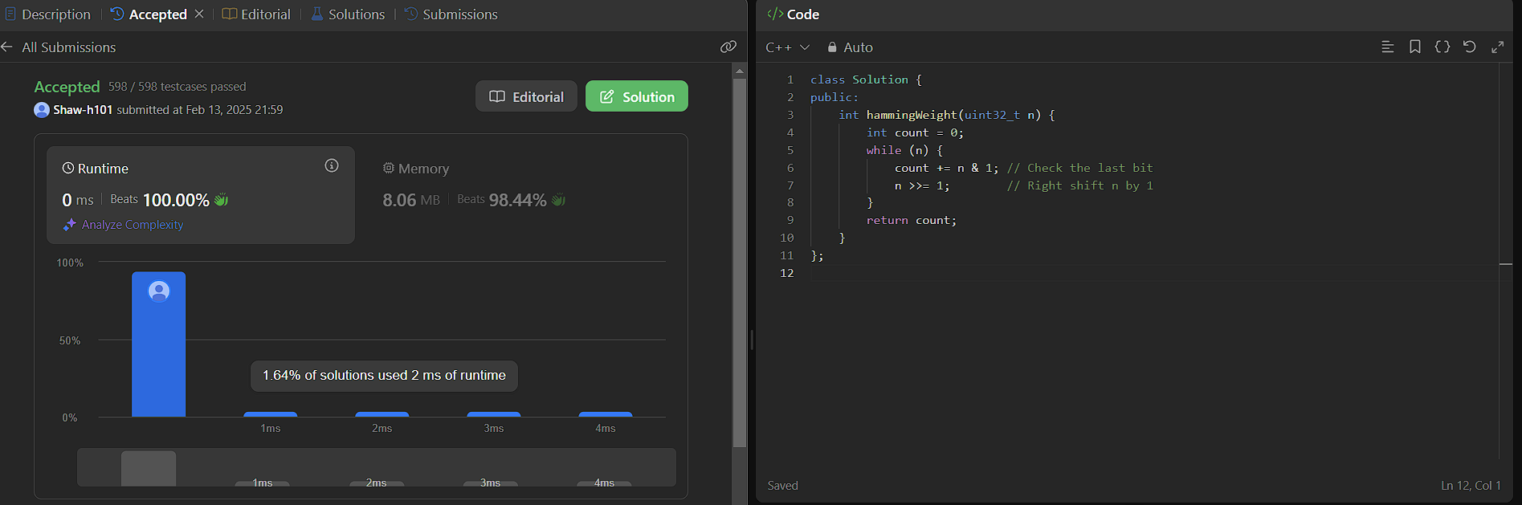

53.[Maximum Subarray](https://leetcode.com/problems/maximum-subarray/description/)

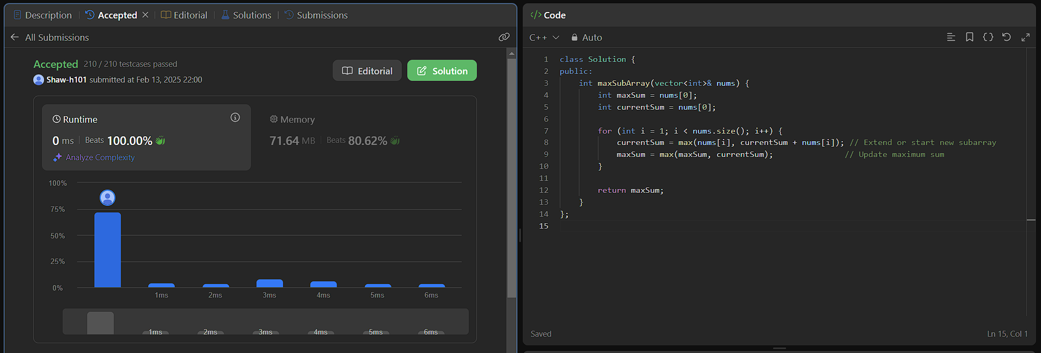

240.[Search a 2D Matrix II](https://leetcode.com/problems/search-a-2d-matrix-ii/description/)

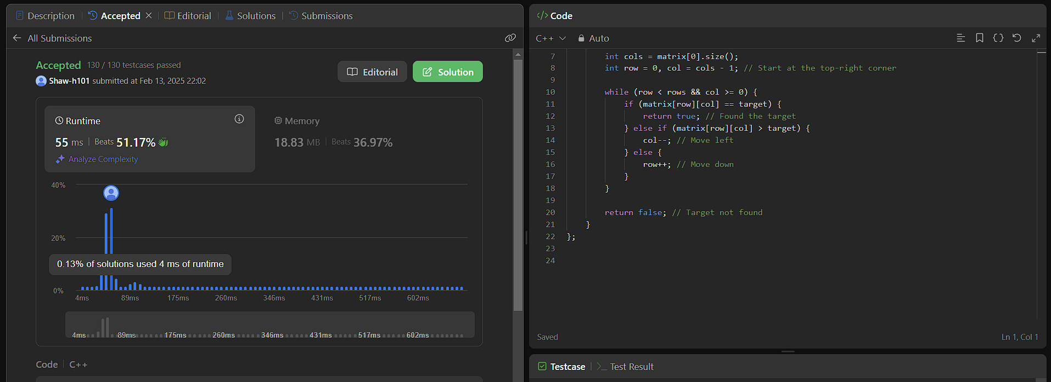

372.[Super Pow](https://leetcode.com/problems/super-pow/description/)

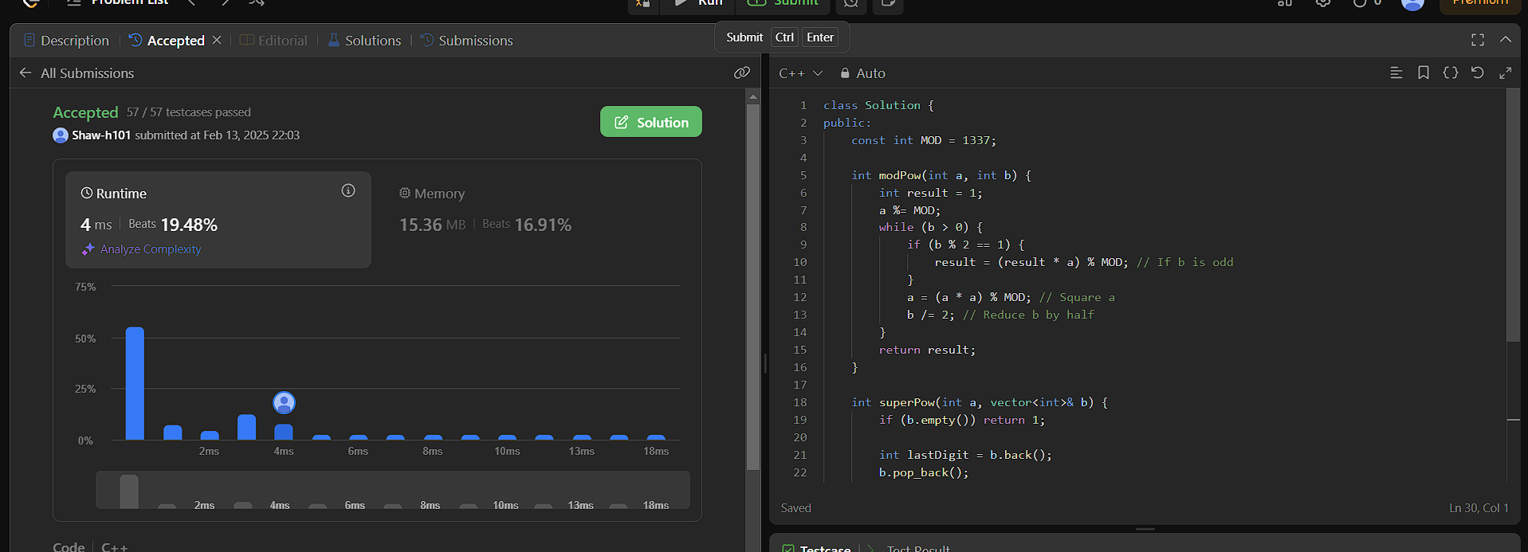

932.[Beautiful Array](https://leetcode.com/problems/beautiful-array/description/)

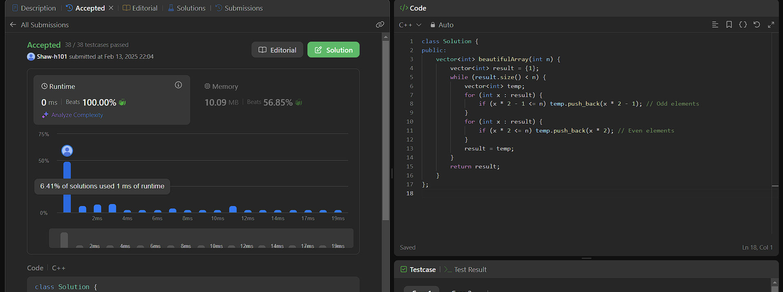

218.[The Skyline Problem](https://leetcode.com/problems/the-skyline-problem/description/)

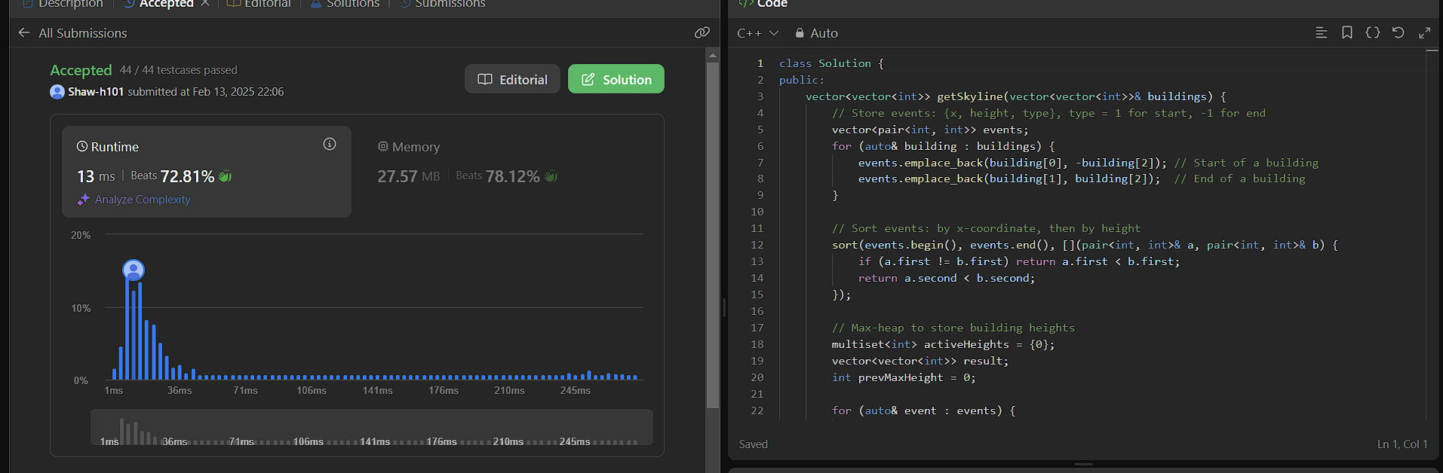

493.[Reverse Pairs](https://leetcode.com/problems/reverse-pairs/description/)

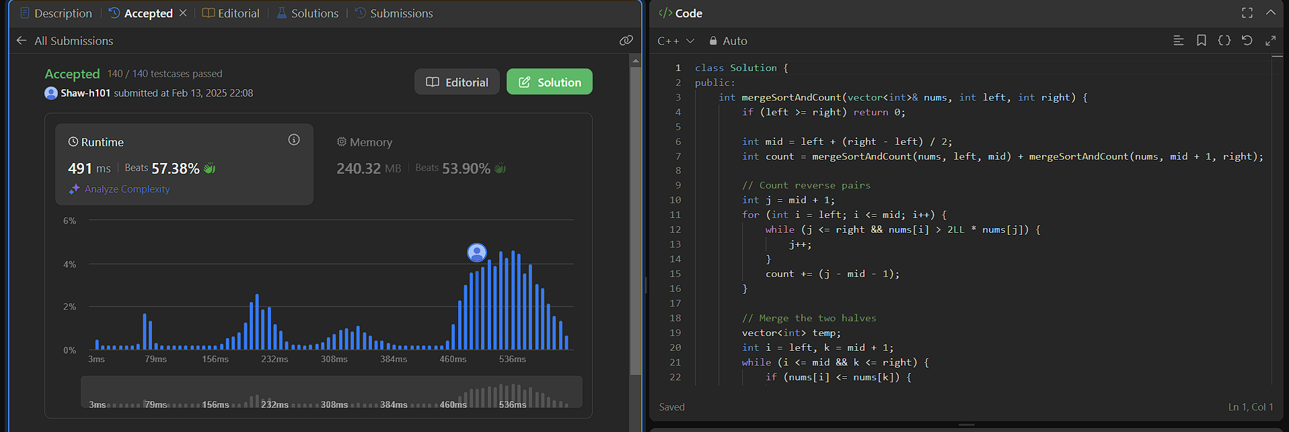

2407.[Longest Increasing Subsequence II](https://leetcode.com/problems/longest-increasing-subsequence-ii/description/)

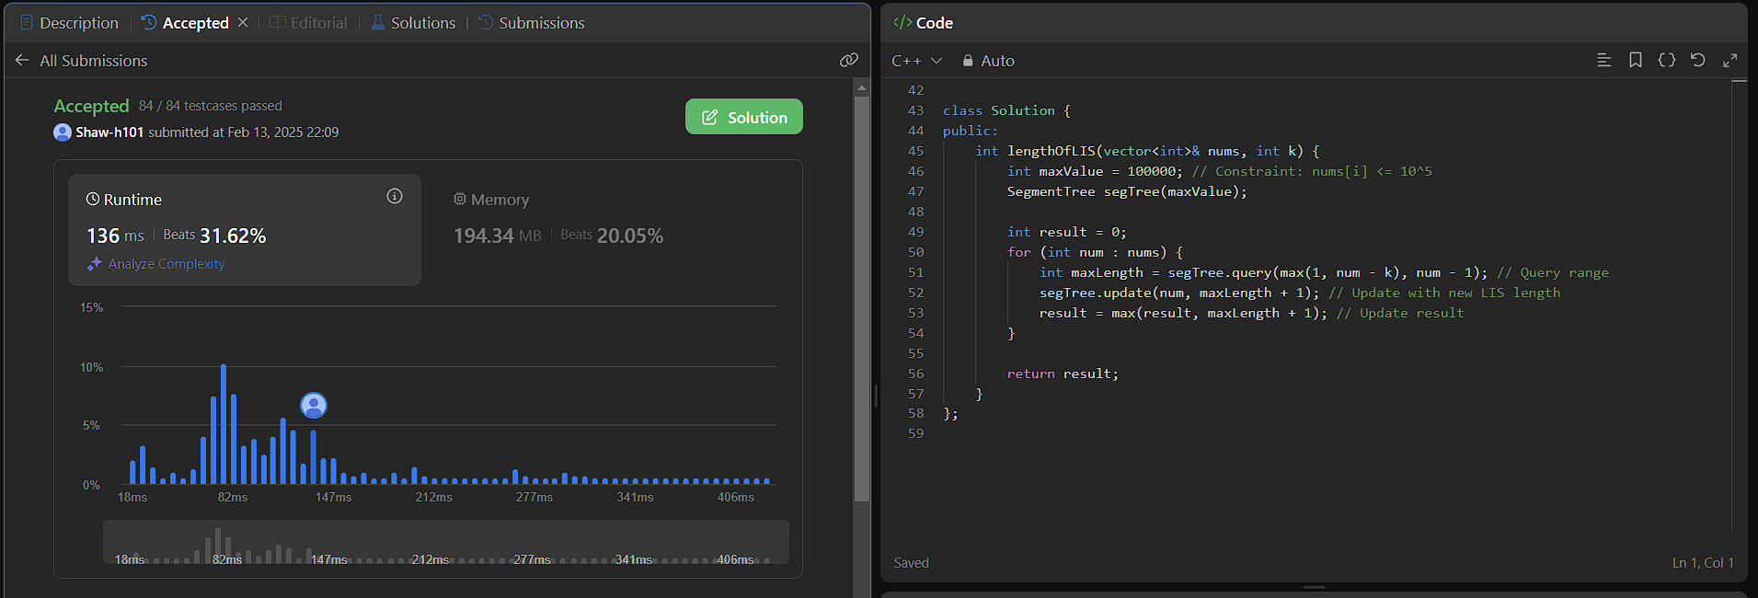

88.[Merge Sorted Array](https://leetcode.com/problems/merge-sorted-array/description/)  
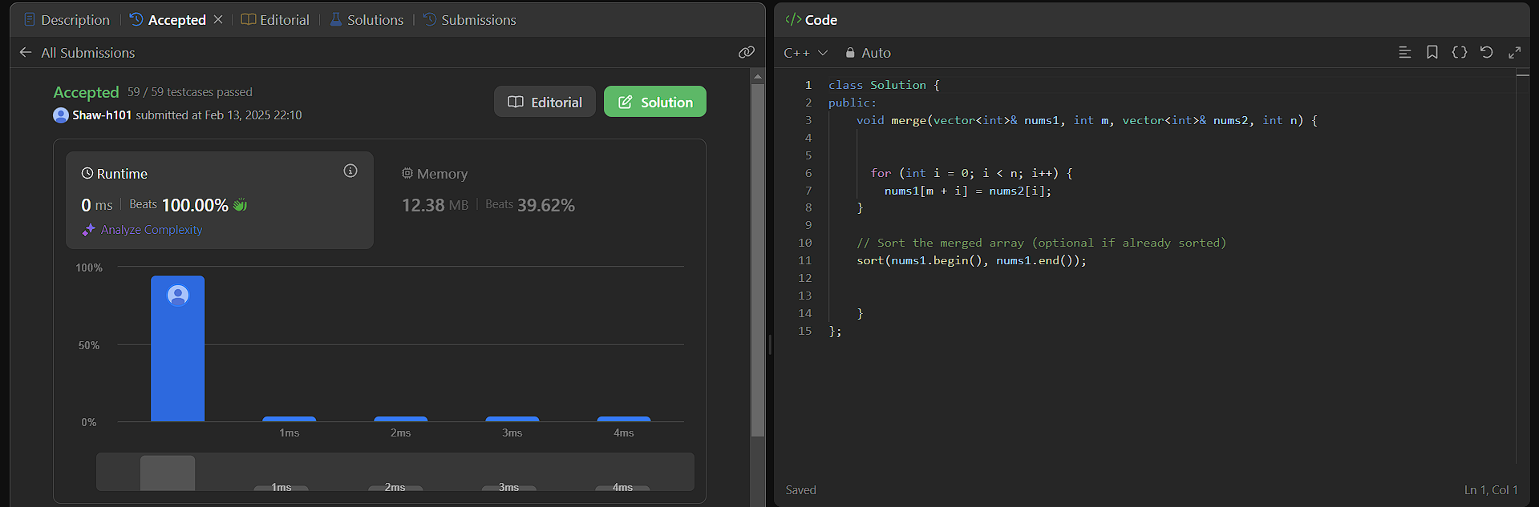

278.[First Bad Version](https://leetcode.com/problems/first-bad-version/description/)  
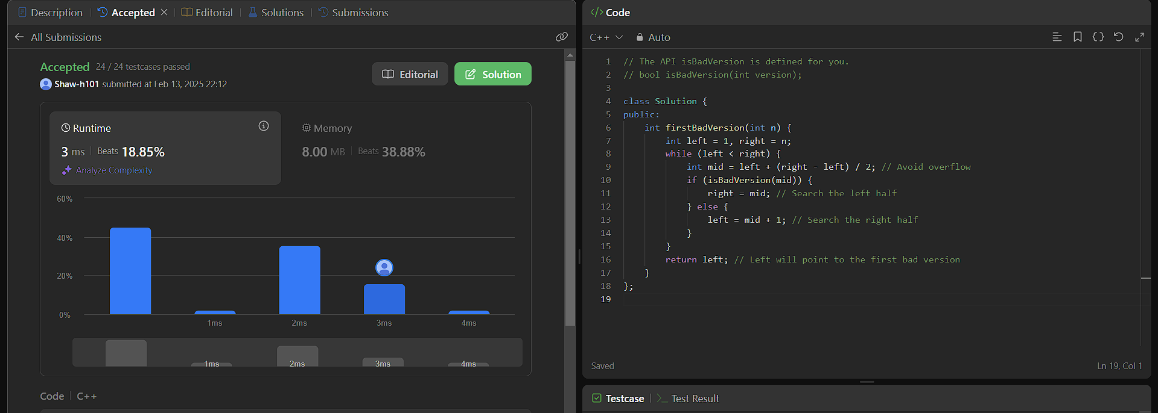

75.[Sort Colors](https://leetcode.com/problems/sort-colors/description/)  
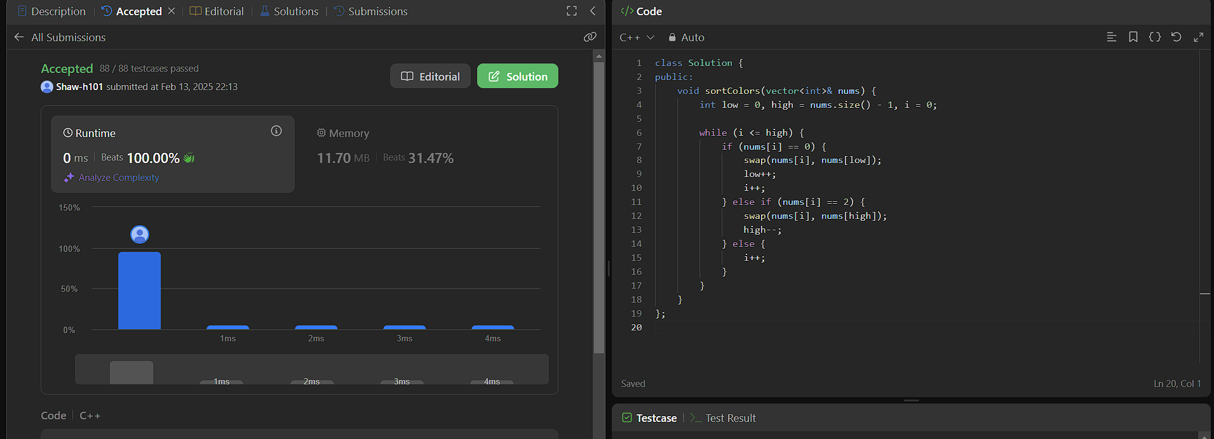

347.[Top K Frequent Elements](https://leetcode.com/problems/top-k-frequent-elements/description/)

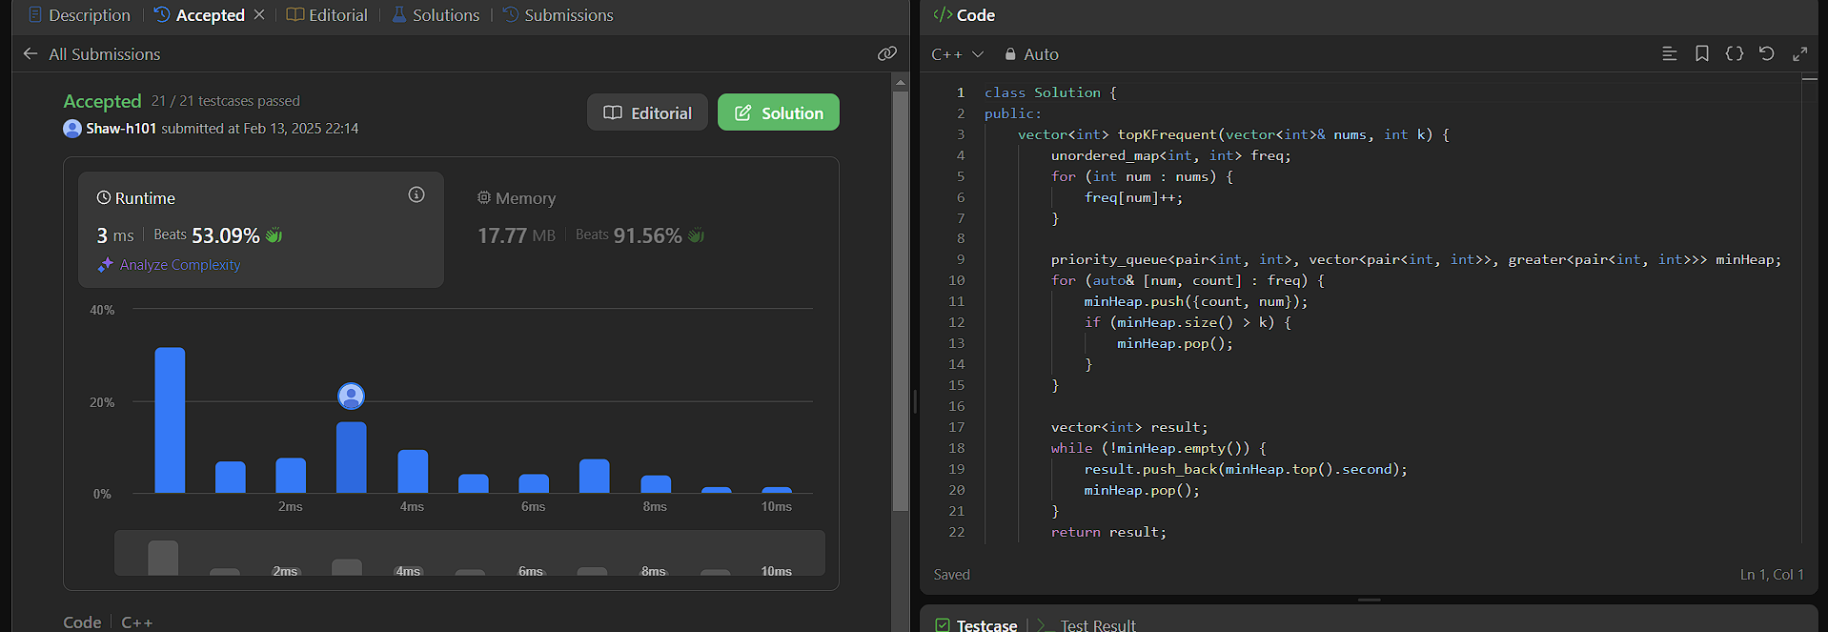

215.[Kth Largest Element in an Array](https://leetcode.com/problems/kth-largest-element-in-an-array/description/)

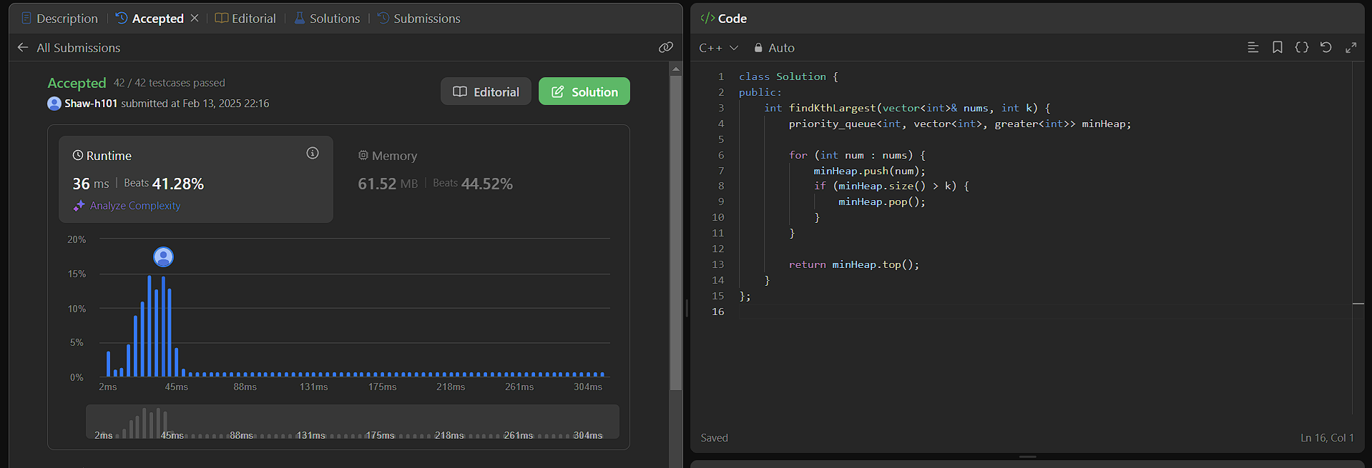

162.[Find Peak Element](https://leetcode.com/problems/find-peak-element/description/)  
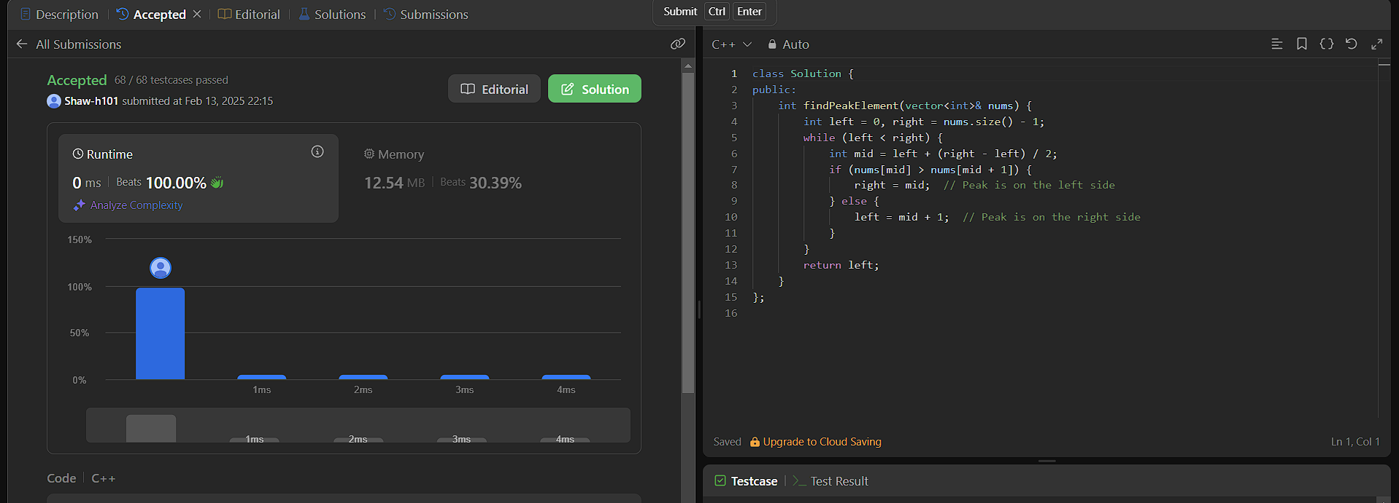

56.[Merge Intervals](https://leetcode.com/problems/merge-intervals/description/)

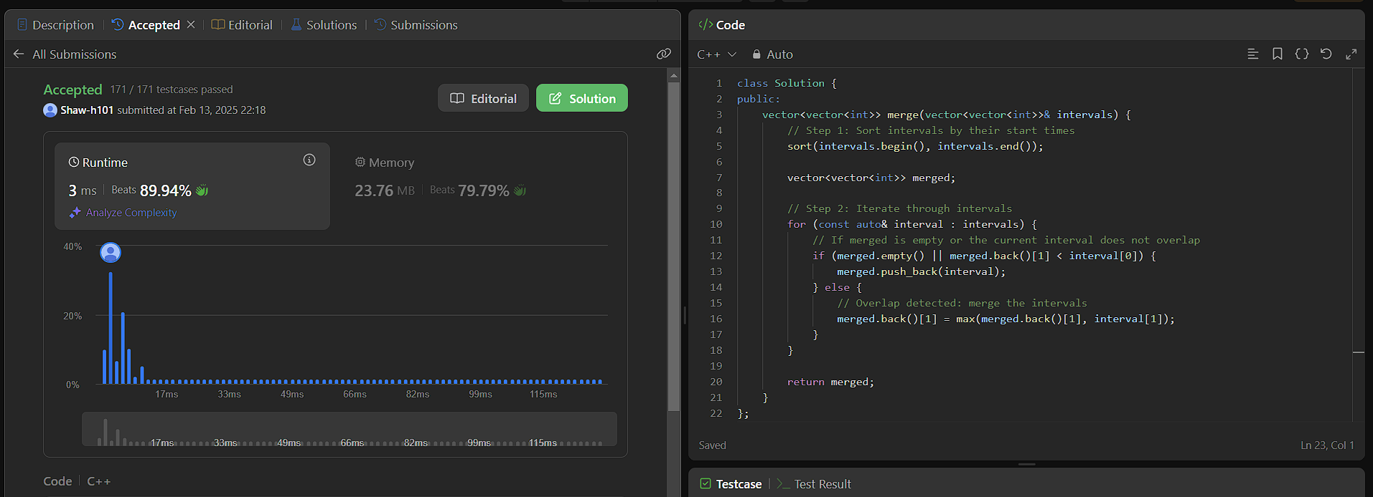

33.[Search in Rotated Sorted Array](https://leetcode.com/problems/search-in-rotated-sorted-array/description/)

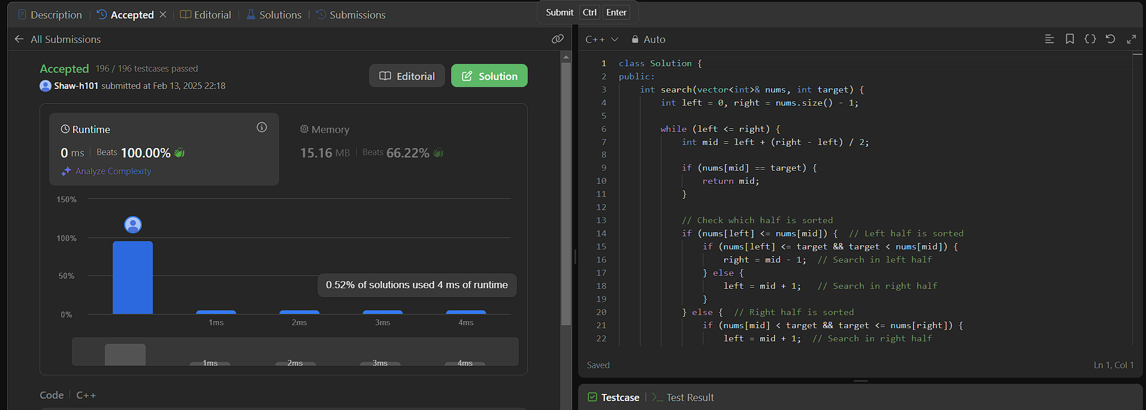

240.[Search a 2D Matrix II](https://leetcode.com/problems/search-a-2d-matrix-ii/description/)

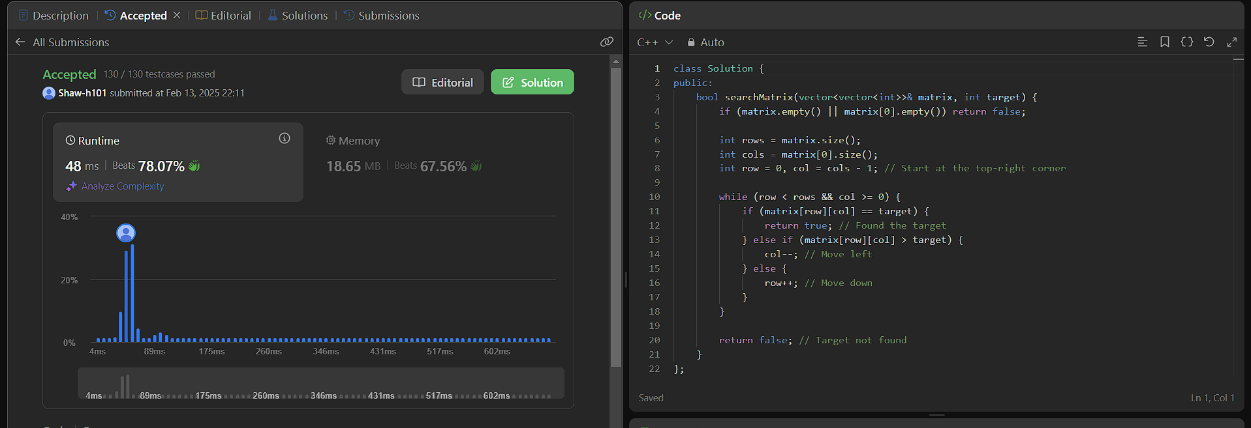

324.[Wiggle Sort II](https://leetcode.com/problems/wiggle-sort-ii/description/)

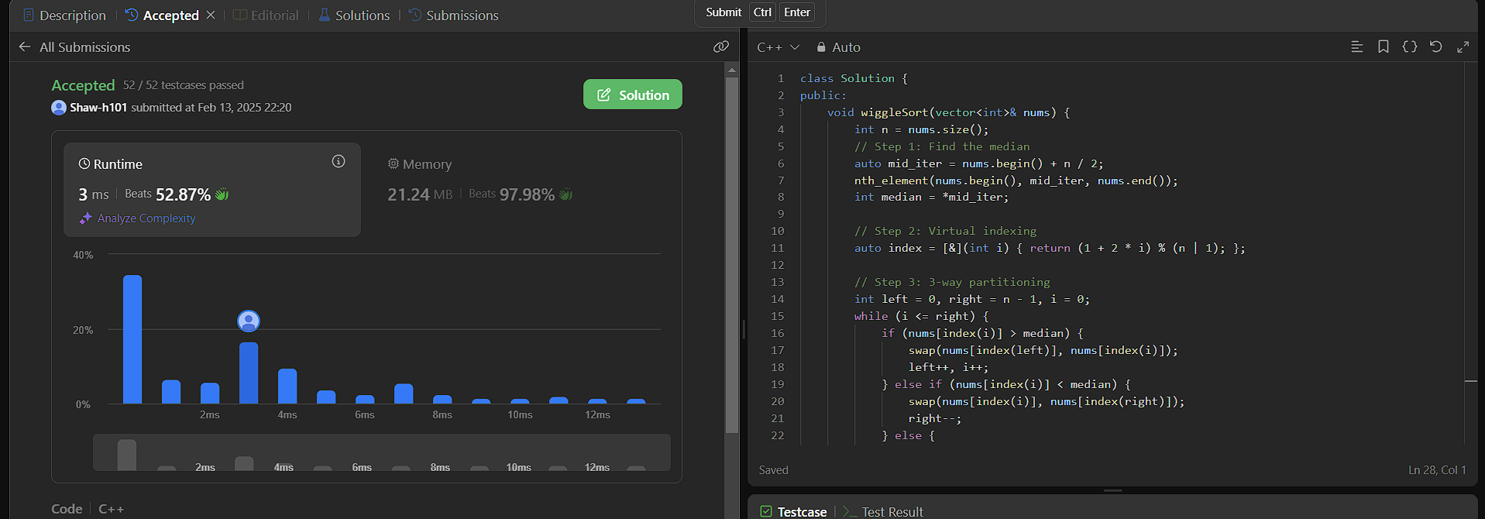

378.[Kth Smallest Element in a Sorted Matrix](https://leetcode.com/problems/kth-smallest-element-in-a-sorted-matrix/description/)

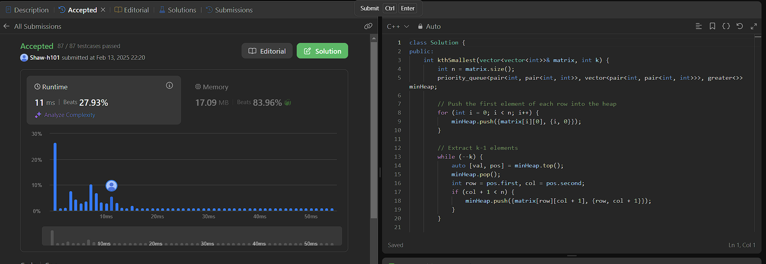

4.[Median of Two Sorted Arrays](https://leetcode.com/problems/median-of-two-sorted-arrays/description/)

